**“ Hotel Reservation System “**

**Adham Tarek Mohamed**

**Bassel saleh moustafa**

**Presented To :**

**Prof. Dr. Hanafy Mahmoud**

**Dr. Mohamed Ezzat**

**Dr. Hazem Omar**

# Project functional View

# Maintain Basic Data:

✓ Hotel ( H_id , H_name , H_location)

✓ Employees ( E_id, E_name, phone, Hob_title, salary, BDate, hotel_id)

✓ Guests (Acc_Number, F_name, L_name, phone, Email, Nationality, hotel_id )

✓ Rooms (Room_Number, R_view, R_level, G_id)

✓ Beds (B_id, B_type, R_No )

✓ Room_Type ( R_type, Rtype, R_No)

✓ Reservation (Res_Number, check_in, Check_out, R_No, G_id)

✓ Bill (Bill_id, G_name, Amount, A_Date, G_id, Type)

# Issue query subsystems:

✓ Search by Employee id

✓ Search by room number

✓ Search by guest id

✓ Search by Room_Number

✓ Search by Hotel_id

✓

# Perform transaction:

✓ Add, delete and update (all entities) ✓ Hotel Name

✓ Guest reservation

# Generate reports:

The Hotels Name

The Guests

The all Guests Reservation

# Planning

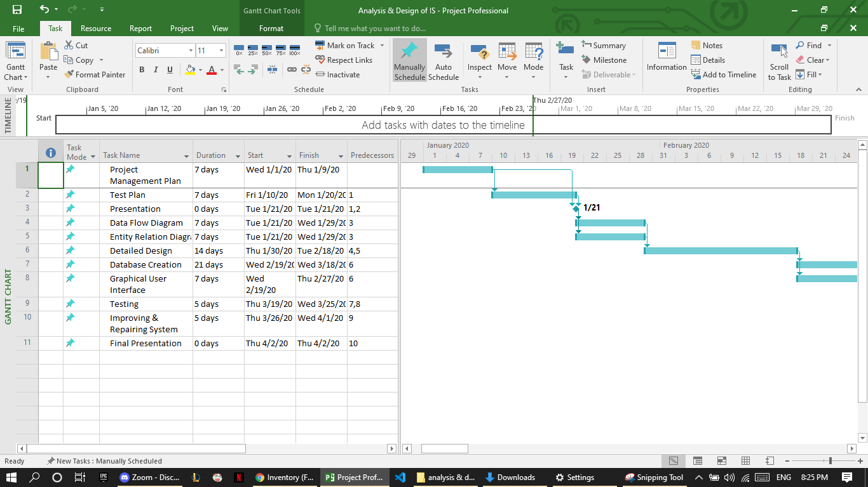

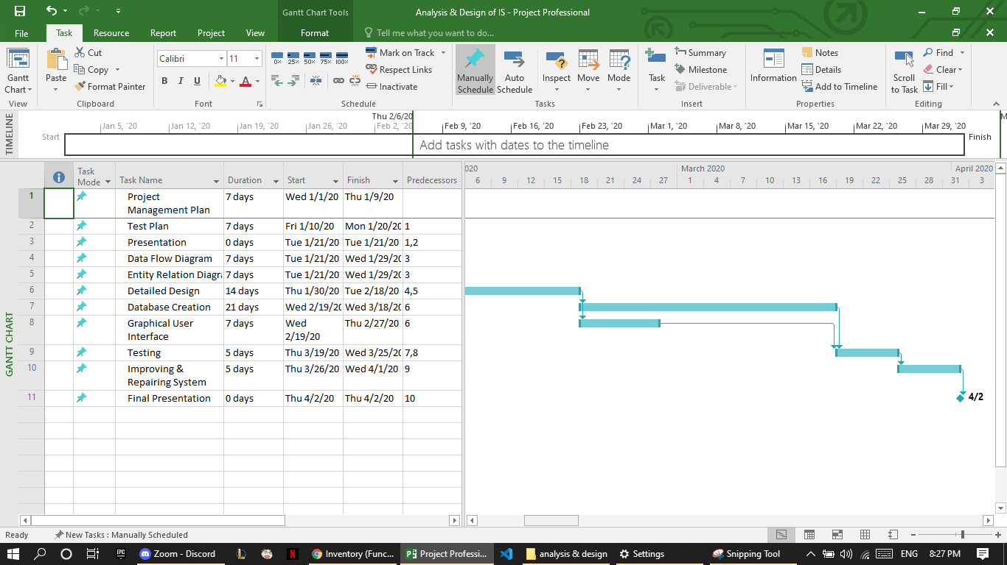

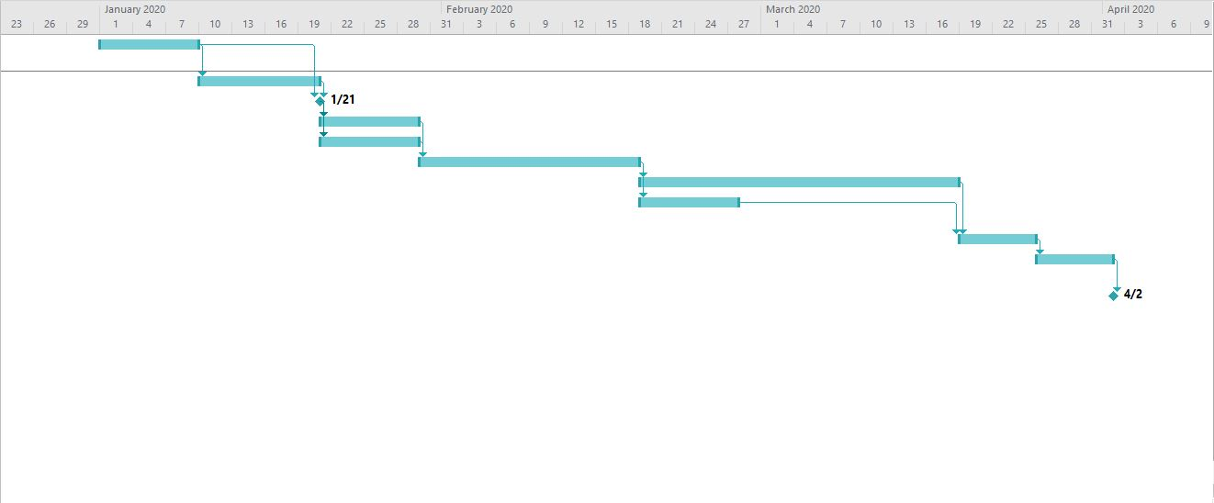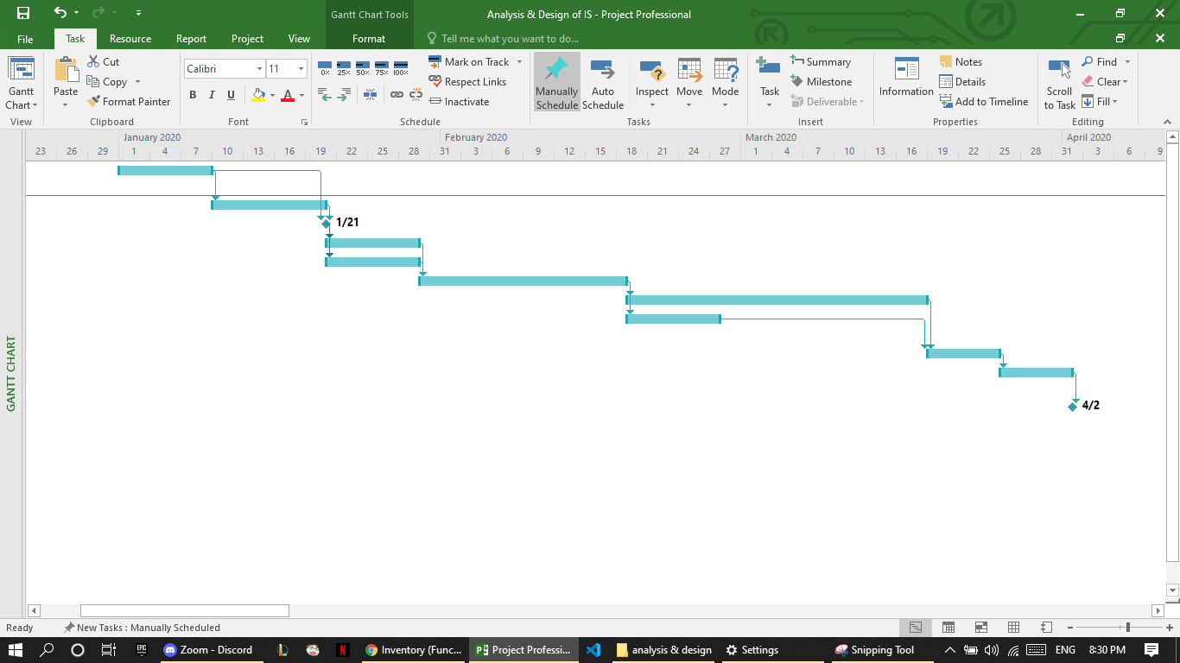

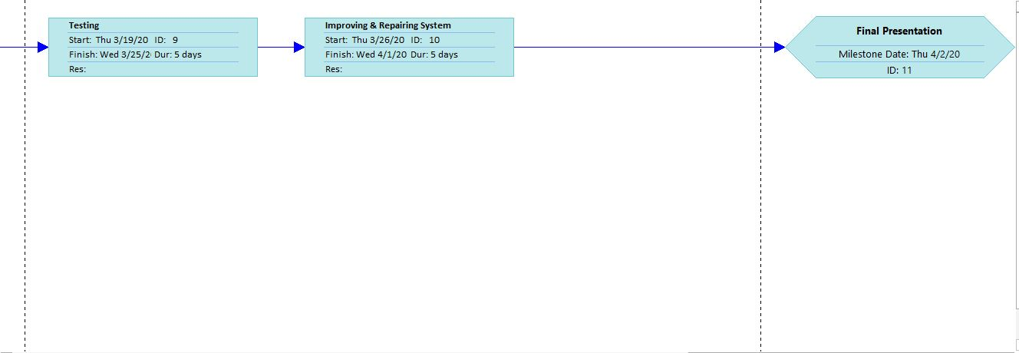

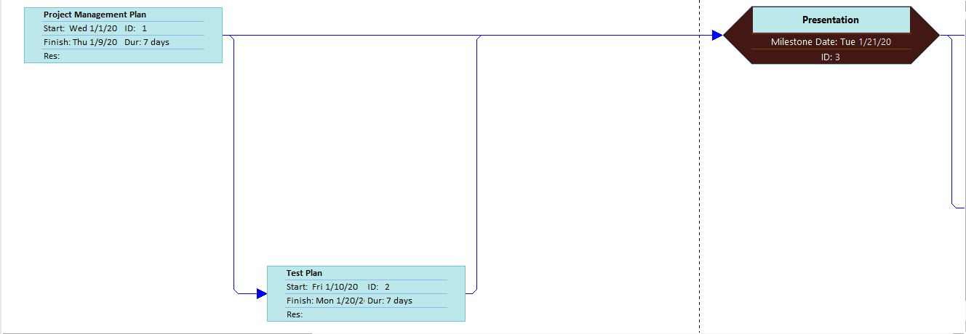

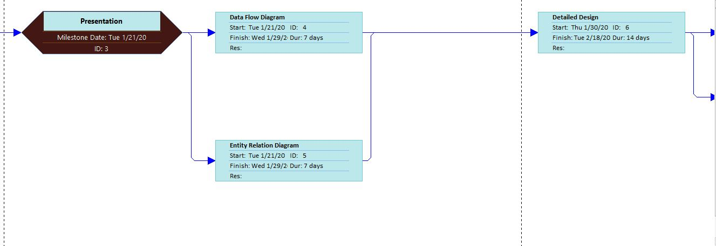

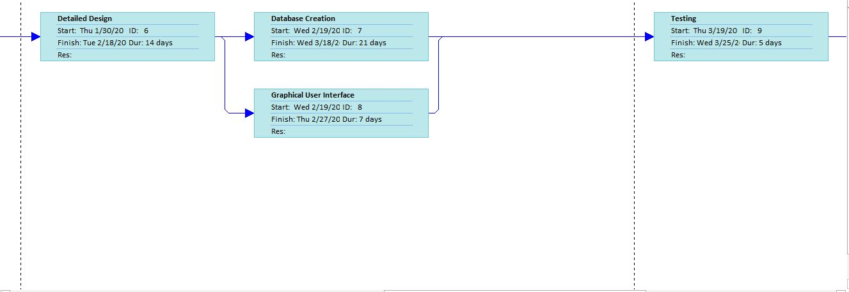

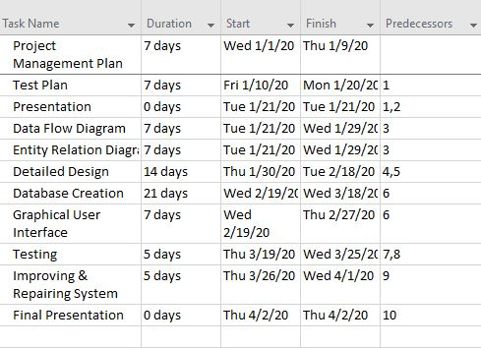

# Network diagram:

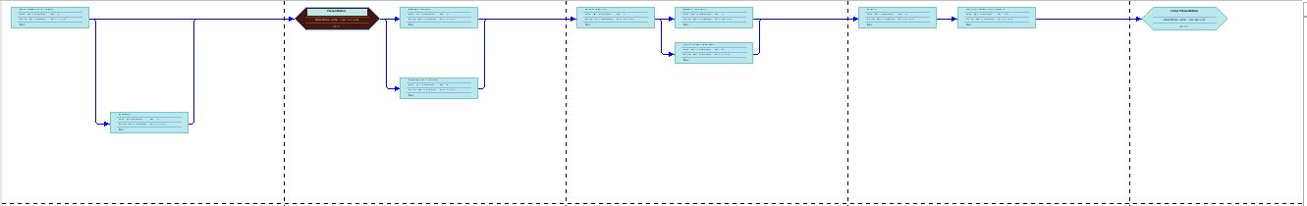

# Context diagram

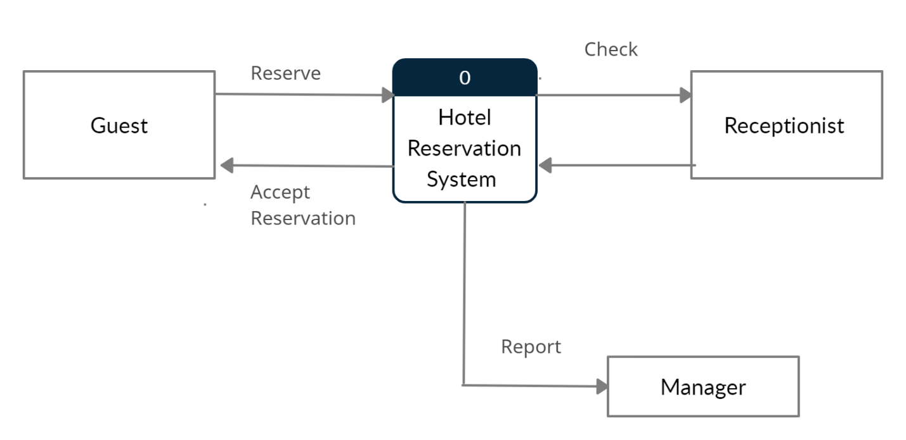

# DFD

# 

# Gui description

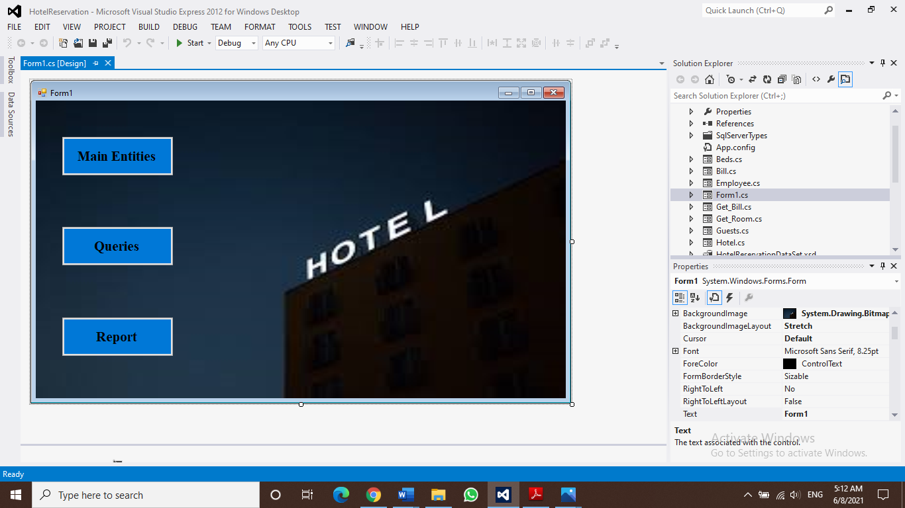

First form that user chooses the step to be done.

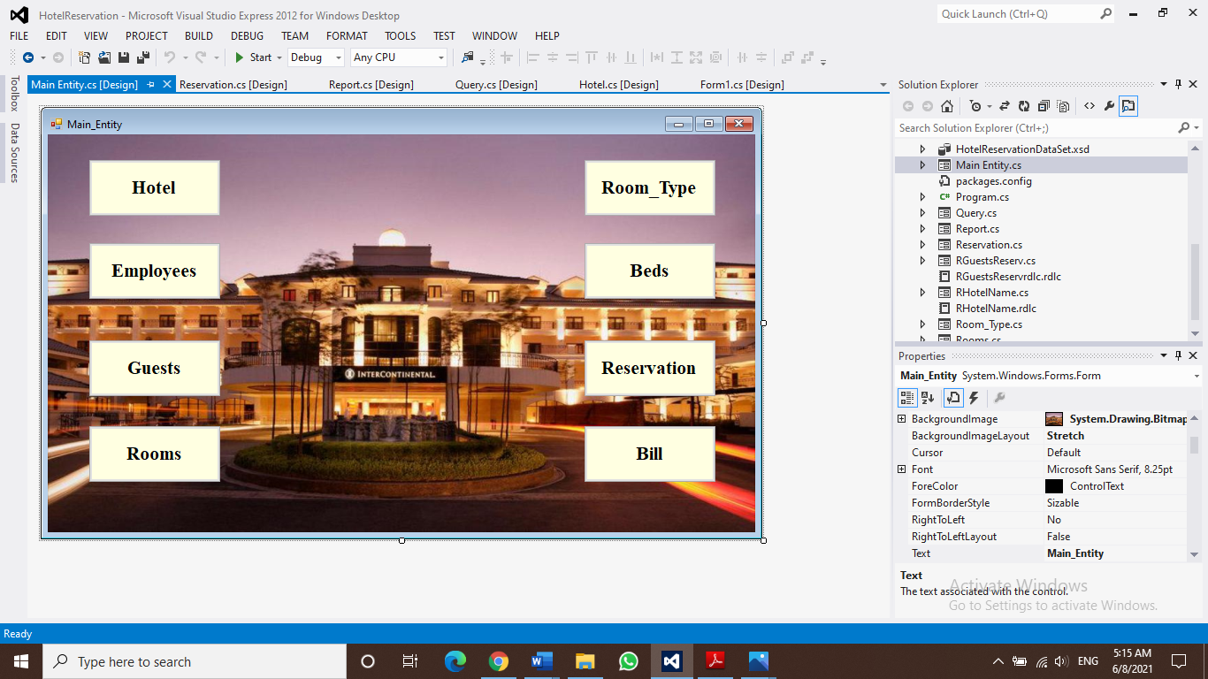

Main Entity form that user chooses which database to add in a new data

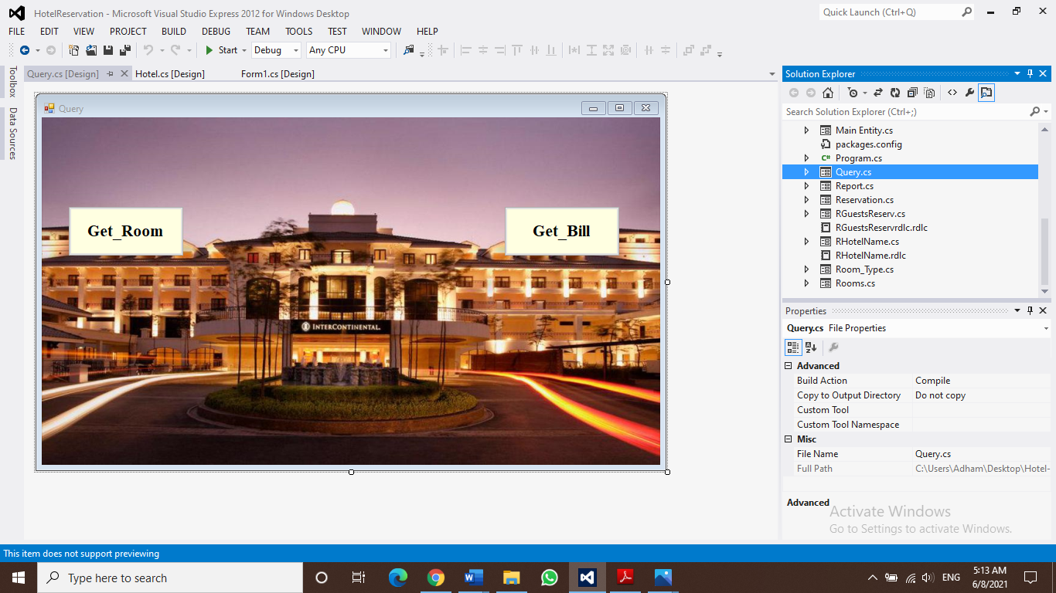

Query form where user gets room data or bill of the guest

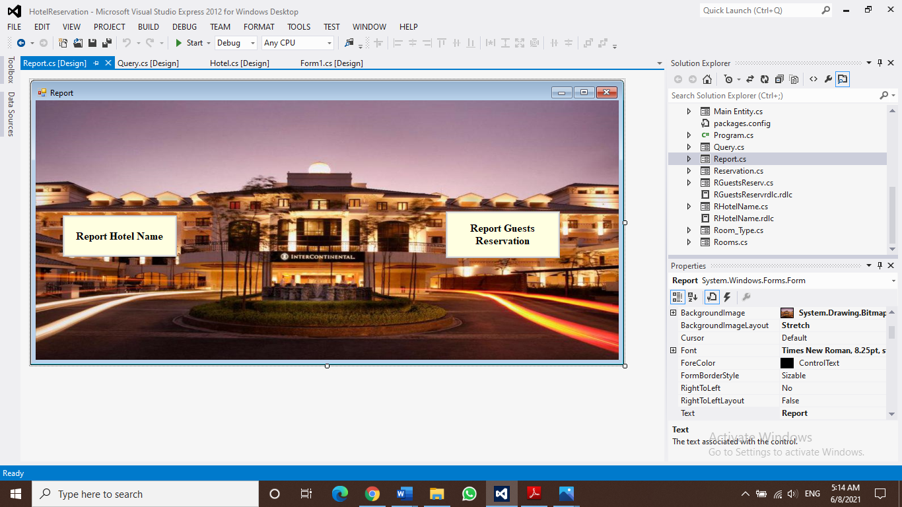

**Report form**

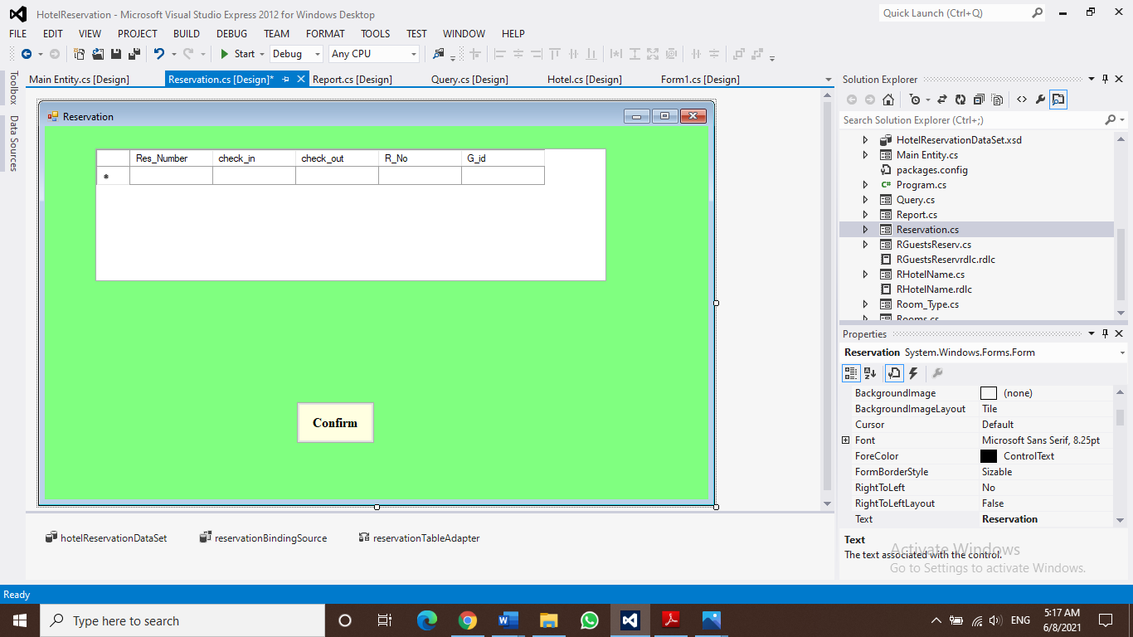

Reservation form to enter reservation data.

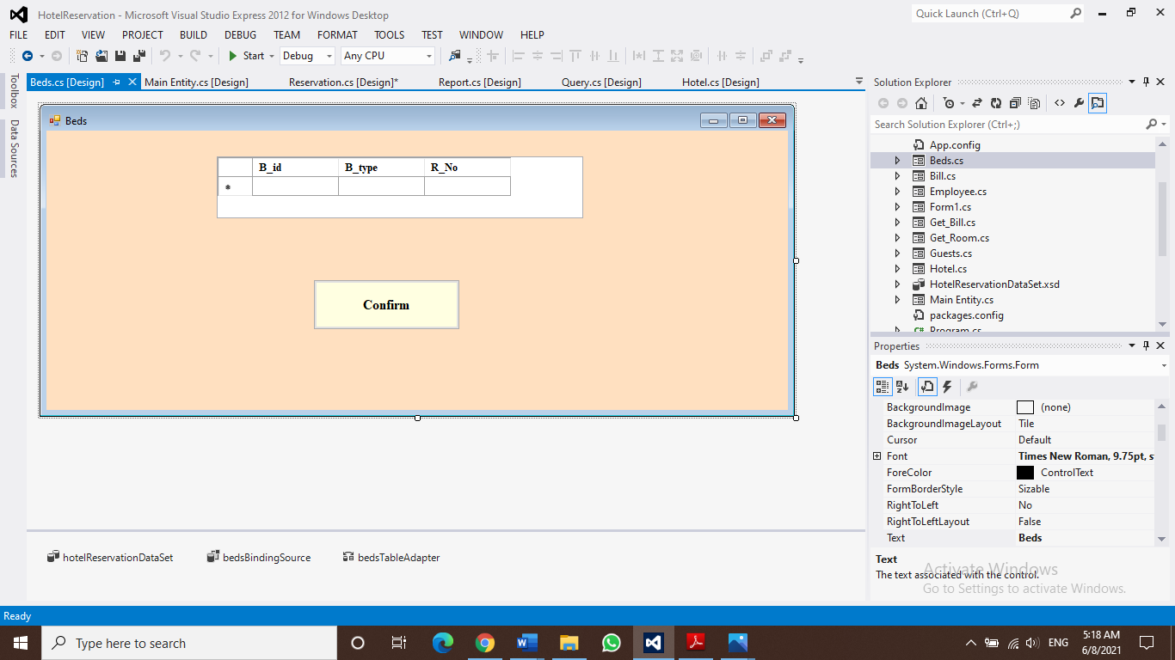

Beds form to enter beds data.

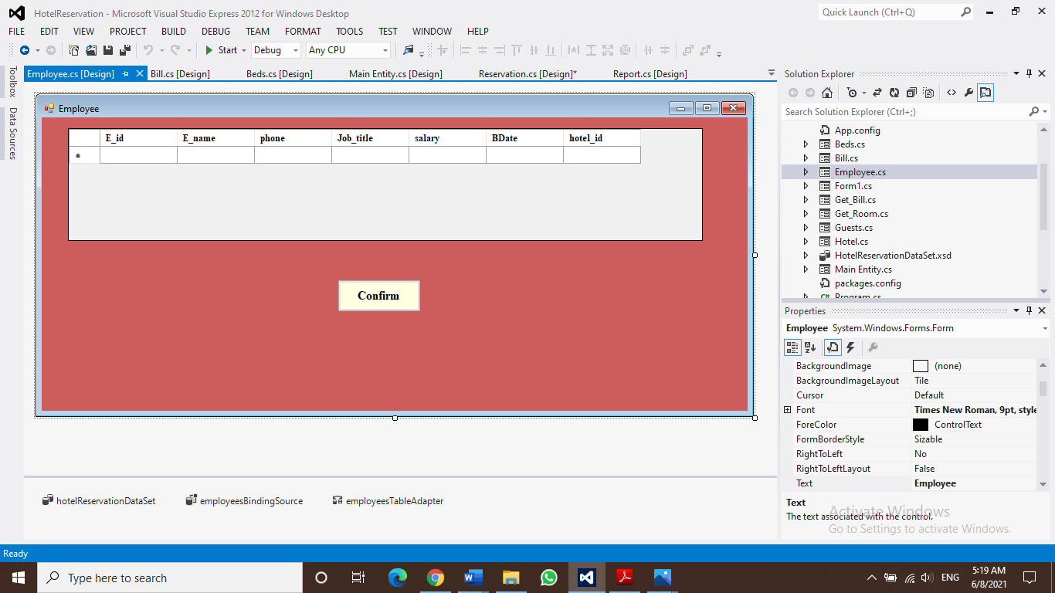

Employee form to enter employee data.

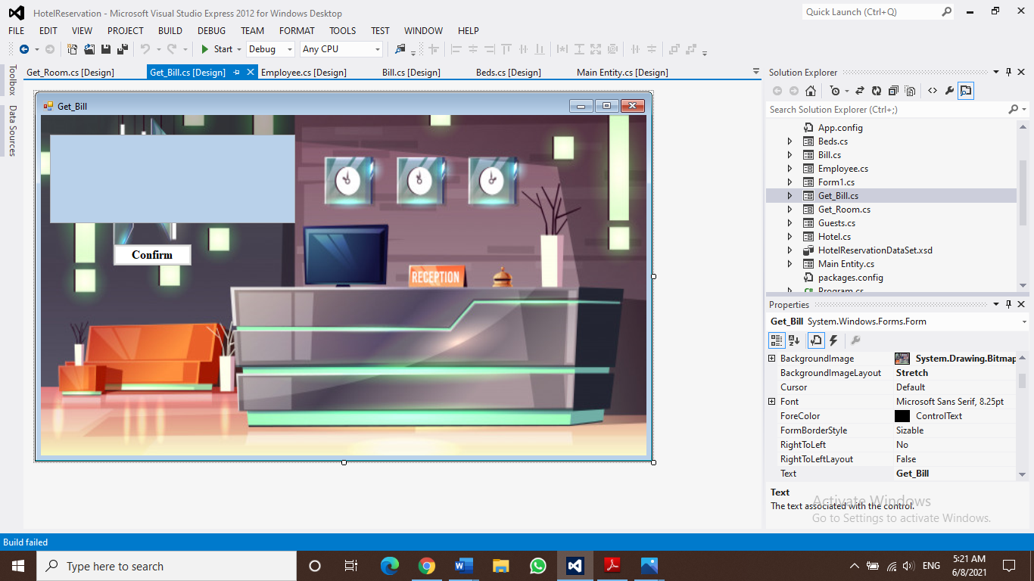

Get bill form to get bill for the guest.

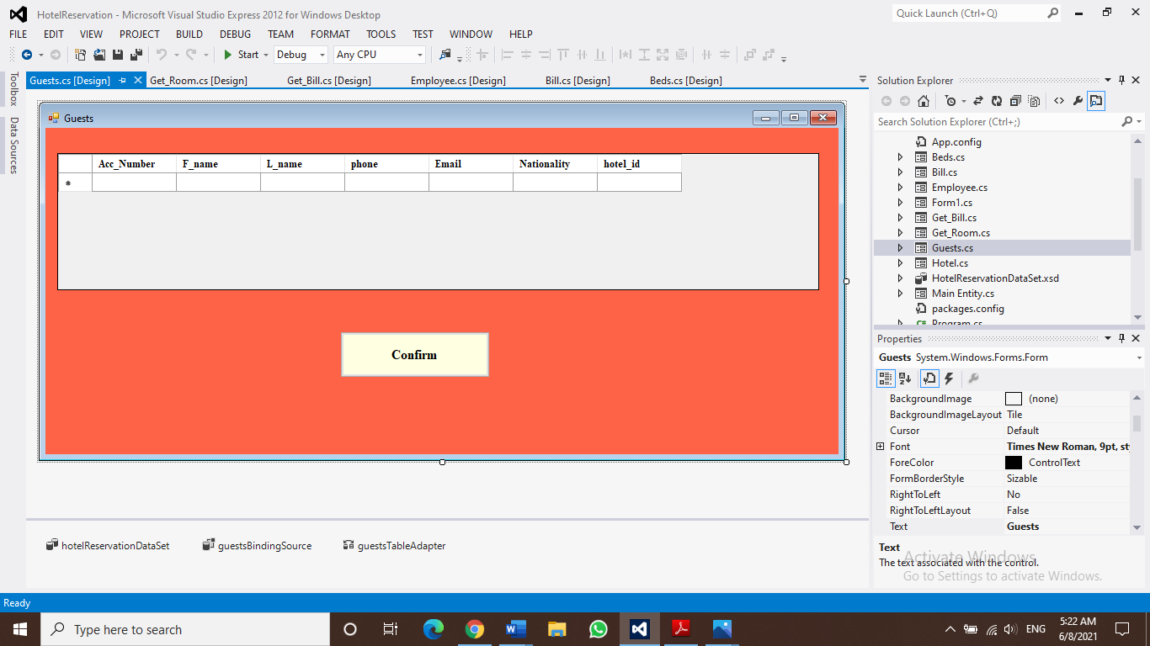

Guests form to enter guests data.

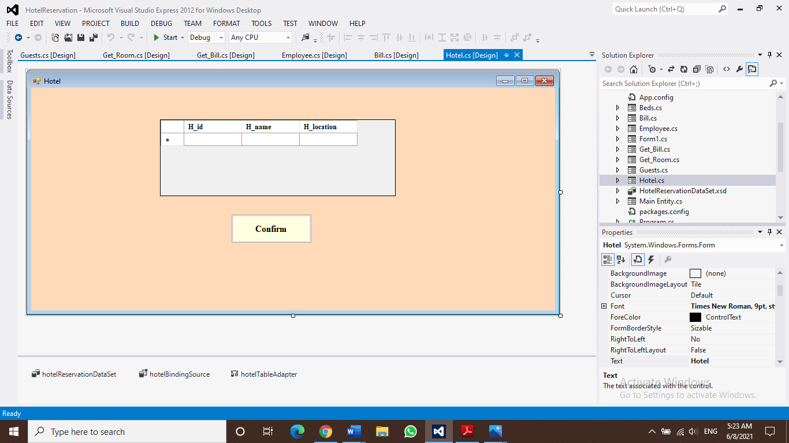

Hotel form to enter hotel data.

# Database design

# Tables:

create table Hotel( H_id int IDENTITY(1,1),H_name varchar(50) not null,H_location varchar(50) not null, constraint pk_Hotel primary key (H_id));

create table Employees ( E_id int identity(1,1), E_name varchar(50) not null,Job_title varchar(50) not null,phone int not null,salary int not null,H_id int i,constraint pk_Employees primary key (E_id),constraint fk_Hotel foreign key (H_id) references Hotel(H_id));

create table Guests(Acc_Number int identity(1,1),F_name varchar(50) not null,L_name varchar(50) not null, phone int not null, Email varchar(50) not null,Nationality varchar(50) not null,H_id int , constraint pk_Guests primary key(Acc_Number),constraint fk_Hotel foreign key (H_id) references Hotel(H_id));

create table Bill( Bill_id int identity(1,1),G_name varchar(50) not null, Amount int not null, B_Date date, B_type varchar(50) not null, Acc_Number int, constraint pk_Bill primary key (Bill_id), constraint fk_Guests foreign key (Acc_Number) references Guests(Acc_Number));

create table Rooms ( Room_Number int identity(1,1), R_view varchar(50) not null, R_level varchar(50) not null, Acc_Number int , constraint pk_Rooms primary key (Room_Number), constraint fk_Guests foreign key (Acc_Number) references Guests(Acc_Number));

create table Room_Type( R_type int identity(1,1), Rtype varchar(50) not null, Room_Number int , constraint pk_Room_Type primary key (R_type), constraint fk_Rooms foreign key (Room_Number) references Rooms(Room_Number));

create table Beds(B_id int identity(1,1),B_type varchar(50) not null, Room_Number int, constraint pk_Beds primary key (B_id),constraint fk_Rooms foreign key (Room_Number) references Rooms(Room_Number));

create table Reservation(Res_Number int identity(1,1),check_in varchar(50) not null, check_out varchar(50) not null, Room_Number int , Acc_Number int , constraint pk_Reservation primary key (Res_Number), constraint fk_Rooms foreign key (Room_Number) references Rooms(Room_Number), constraint fk_Guests foreign key (Acc_Number) references Guests(Acc_Number));

# Mapping:

Hotel(H_id,H_name,H_location)

Employees(E_id,E_name,job_title,phone,salary,H_id)

Guests(Acc_number,F_name,L_name,phone,Email,Nationality,H_id)

Reservation(Res_number,check_in,check_out,R_No,G_id)

Bill(Bill_id,G_name,Amount,B_Date,G_id,Type)

Room_type(R_type,Rtype,R_no)

Rooms(Room_number,R_view,R_level,G_id)

Beds(B_id,B_type,R_No)

# E R diagram:

# 

# Relational Model :

